KHOA CÔNG NGHỆ THÔNG TIN
TRƯỜNG ĐẠI HỌC GIAO THÔNG VẬN TẢI
TP.HỒ CHÍ MINH
____________________________


BÁO CÁO
CÔNG NGHỆ PHẦN MỀM
Giảng Viên: Trần Thị Mỹ Tiên

TP.HCM – NĂM 2026

Phone Book Management System
Specification

TABLE OF CONTENTS
I. Functional Requirements
II. Non-Functional Requirements
III. Data Flow Diagram
1. Level 0
2. Level 1
IV. Use Case Diagram
V. Class Diagram
VI. Data Model

Functional Requirements
- Contact Management
- Add a new contact to the phone book, including full name, phone number, email address, physical address, profile picture, and notes.
- The system validates input data, requiring a full name and phone number, and checks the validity of the phone number.
- Update the information of an existing contact.
- Delete one or multiple contacts from the phone book. The system displays a confirmation dialog before permanently deleting the selected contacts.
- Search for contacts by name, phone number, or email address.
- The system supports partial matching when users enter search keywords.
- Sort contacts alphabetically in ascending (A–Z) or descending (Z–A) order.
- Allow users to mark contacts as favorites or remove them from the favorites list.
- Favorite List Management
- The system displays a separate list of contacts marked as favorites.
- Users can add contacts to or remove contacts from the favorites list without deleting their information from the main contact list.
- The system allows users to sort the favorites list by priority level or frequency of communication.
- Phone and Contact Management
- Users can create, edit, and delete contact groups (e.g., Family, Work, and Friends).
- Users can assign contacts to groups or remove contacts from groups.
- The system displays detailed contact profiles, including secondary phone numbers, work addresses, birthdays, and personal notes.
- The system detects contacts with duplicate names or phone numbers and suggests merging or deleting duplicate records.
- User Account Management
- The Admin can view a list of all user accounts registered in the system.
- The Admin can search for user accounts by username or email address.
- The Admin can view detailed information about a user account.
- The Admin can lock a user account to prevent the user from logging into the system.
- The Admin can unlock a locked account, allowing the user to access the system again.
- The Admin can monitor account statuses, including active and locked.

- Account Management
- Users can log in to and log out of the system using their username or email address and password.
- Users can change their passwords by verifying their current passwords and setting new ones.
- Users can register for an account to use the system.
- Users can view and update their personal information, including full name, email address, profile picture, and personal phone number.
II. Non-Functional Requirements
1. Performance
- The system must display the contact list within 2 seconds under normal operating conditions.
- The system must return search results within 2 seconds, even when searching through a database containing 10,000+ contacts.
- The system must support at least 100 concurrent users without significant performance degradation.
- Adding, updating, or deleting a contact must be processed within 2 seconds.
2. Security
- The system requires user authentication (login) before allowing access to personal contact information.
- Passwords must be encrypted or securely hashed before being stored in the database.
- The system must implement role-based access control to distinguish between Admin and regular Users.
- Only the Admin is allowed to view, lock, and unlock user accounts.
- Users can only access and manage their own contact information.
- The system must protect personal information from unauthorized access, modification, or disclosure.

3. Availability and Reliability
- The system must be available at least 99% of the time during normal operation.
- The system must handle invalid inputs (e.g., incorrect phone numbers, invalid email addresses, or missing required fields) without crashing.
- The system must automatically save changes to prevent data loss.
- The system must maintain stable operation during continuous use without unexpected errors.
- The system must provide appropriate error messages when operations fail.
4. Usability
- The user interface must be simple, intuitive, and easy to navigate.
- The system must provide clear instructions, labels, and error messages to guide users through each function.
- Users must be able to perform common operations, such as adding, searching, editing, and deleting contacts, with minimal steps.
- The system must display confirmation messages after successfully completing important operations.
- The system must provide a confirmation dialog before permanently deleting contacts or performing other critical actions.
5. Scalability
- The system must support an increasing number of users and contacts without significant performance degradation.
- The database structure must allow the storage and management of at least 100,000 contact records.
- The system architecture must allow new features, such as contact synchronization, contact import/export, and additional contact groups, to be added without major changes to existing components.
6. Maintainability
- The source code must be clearly structured, well-organized, and easy to understand, maintain, and upgrade.
- The system must use modular components to simplify debugging and future development.
- Technical documentation must be complete and accurate.
- The system must allow developers to fix bugs and update individual components without significantly affecting other functions.
7. Data Integrity and Backup
- The system must ensure that contact information remains accurate and consistent throughout all operations.
- The system must prevent duplicate contact records when adding or updating contacts.
- The system must automatically back up important data to prevent permanent data loss.
- The system must support data recovery in case of system failures or unexpected errors.
- Deleting a contact from the favorites list must not delete the contact from the main contact list.
8. Technology Constraints:
- The system will be developed as a web-based application.
- Programming language: Python.
- Design UX/UI: Figma
- Database Management System: PostgreSQL.
- Deployment environment: A web server running on Linux or Windows Server.
III. Data Flow Diagram
- Level 0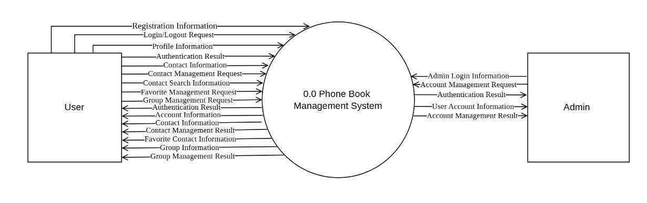

- Level 1
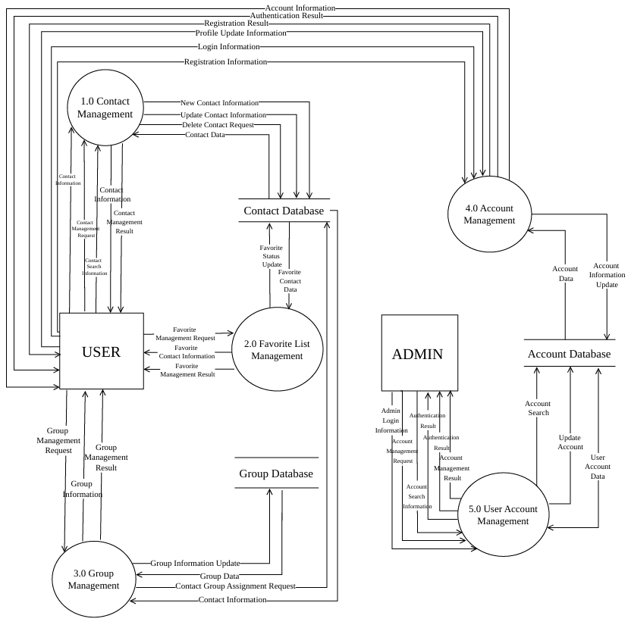

3. Level 2
  - Contact Management
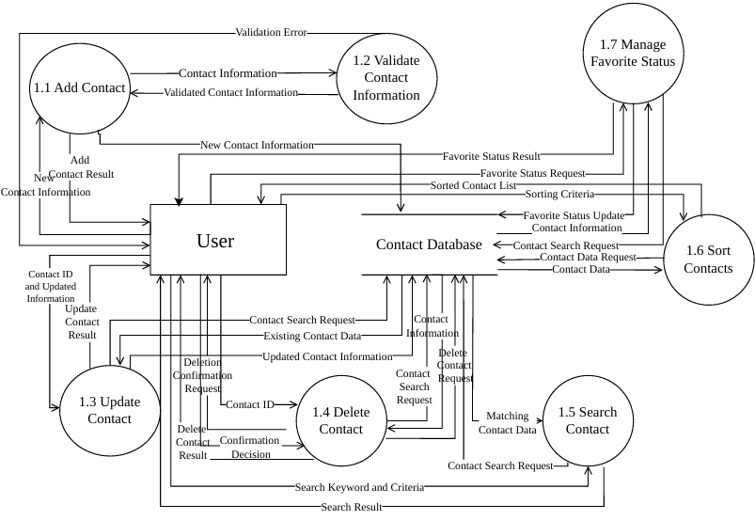
  - Favorite List Management
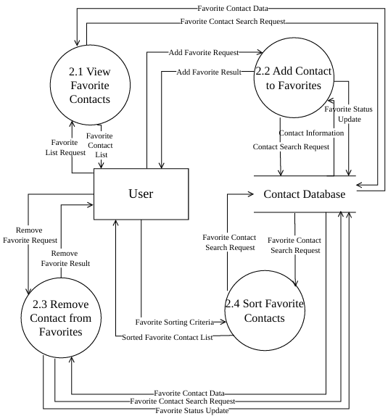

  - Group Management
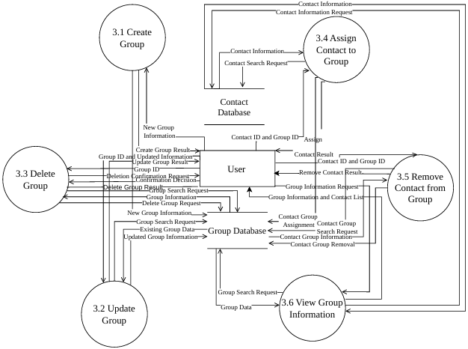
  - Account Management
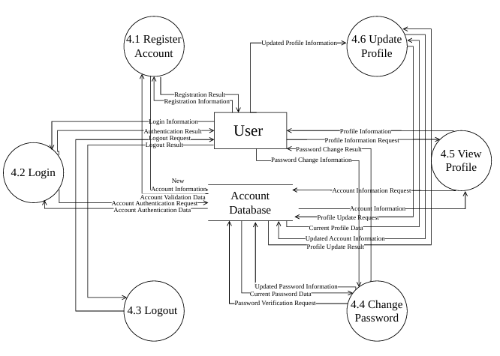

  - User Account Management
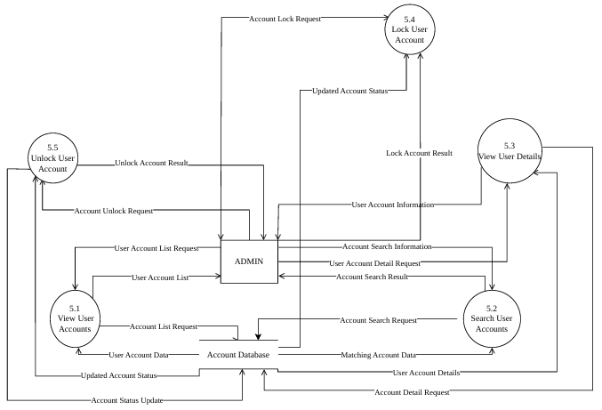

IV. Use Case Diagram
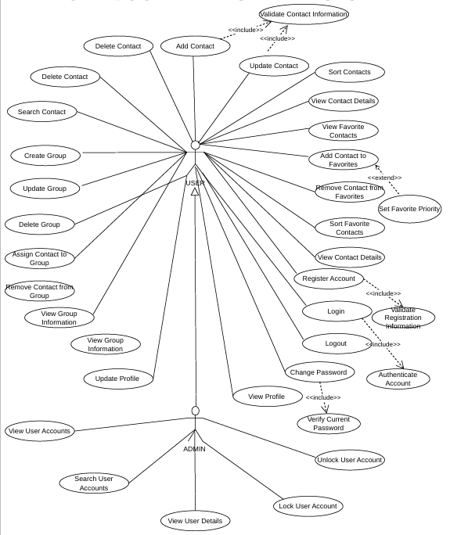
A. Overall Use Case Diagram

B. List
1. List of Actor

STT | Actor | Description
1 | User | A user of the phone book management system can register, log in, log out, manage their personal account (view and update profile, change password), manage contacts (add, edit, delete, search, sort, detect and merge duplicate contacts), manage favorite contacts, and organize contacts into groups.
2 | Admin | An administrator is responsible for managing user accounts, viewing and searching for users, viewing user details, monitoring account statuses, and locking or unlocking user accounts.

2. List of Use Cases
2.1 User
STT | Use Case | Description
 | Register Account | Allows users to create a new account to access the phone book management system.
 | Login | Allows users to log in to the system using their username or email and password.
 | Logout | Allows users to securely log out of the system.
 | View Profile | Allows users to view their personal account information.
 | Update Profile | Allows users to update their personal information, such as full name, email, phone number, and avatar.
 | Change Password | Allows users to change their account password after verifying their current password.
 | Add Contact | Allows users to add new contacts to their personal contact book by entering contact information.
 | Update Contact | Allows users to modify existing contact information, including name, phone numbers, email, address, and notes.
 | Delete Contact | Allows users to remove contacts from their personal contact book.
 | Search Contact | Allows users to search for contacts by name, phone number, email, or other supported information.
 | Sort Contacts | Allows users to sort their contact list based on selected criteria, such as contact name.
 | View Contact Details | Allows users to view detailed information about a specific contact, including available phone numbers and personal information.
 | Validate Contact Information | Checks the validity of contact information before the system saves or updates a contact.
 | Create Group | Allows users to create a new group to organize their contacts.
 | Update Group | Allows users to modify existing group information, such as the group name and description.
 | Delete Group | Allows users to delete an existing contact group without deleting the contacts belonging to it.
 | Assign Contact to Group | Allows users to assign existing contacts to a selected group
 | Remove Contact from Group | Allows users to remove contacts from a group without deleting them from the contact book.
 | View Group Information | Allows users to view detailed information about a group and its associated contacts.
 | View Favorite Contacts | Allows users to view their list of favorite contacts.
 | Add Contact to Favorites | Allows users to add a contact to their favorite list for quick access.
 | Remove Contact from Favorites | Allows users to remove a contact from their favorite list without deleting the contact itself.
 | Sort Favorite Contacts | Allows users to sort their favorite contacts based on selected criteria.

2.2 Admin

STT | Use case | Description
 | View User Accounts | Allows administrators to view all user accounts registered in the system.
 | Search User Accounts | Allows administrators to search for user accounts using keywords such as username, email, or other supported information.
 | View User Details | Allows administrators to view detailed information about a specific user account.
 | Lock User Account | Allows administrators to lock a user account to prevent the user from accessing the system.
 | Unlock User Account | Allows administrators to unlock a previously locked user account and restore access to the system.
 | User Account Management | Allows administrators to manage user accounts, including viewing, searching, checking account details, locking, and unlocking accounts.

3. Use Case Specification
3.1 Register Account

3.1.1 Summary
- Allows new users to create an account by providing personal information, username, email, and password.

3.1.2. Flow of Events

3.1.2.1 Main Flow
- User selects Register Account.
- System displays the registration form.
- User enters the required information.
- System validates the registration information.
- System creates a new account.
- System displays a success message.

3.1.2.2 Alternative Flow
- If required information is missing or invalid, the system displays an error message.
- If the username or email already exists, the system requests different information.

3.1.3. Special Requirements
- Username and email must be unique.
- Password must be stored securely.

3.1.4. Precondition
- User does not have an existing account.

3.1.5. Postcondition
- A new user account is successfully created.

3.1.6. Extension Points
- Validate Registration Information.
3.2. Login

3.2.1. Summary
- Allows users to access the system using their username or email and password.

3.2.2. Flow of Events

3.2.2.1. Main Flow
- User selects Login.
- System displays the login form.
- User enters username/email and password.
- System authenticates the account.
- System grants access to the system.

3.2.2.2. Alternative Flow
- If the credentials are incorrect, the system displays an error message.
- If the account is locked, the system denies access.

3.2.3. Special Requirements
- Passwords must be verified securely.

3.2.4. Precondition
- User has an existing account.

3.2.5. Postcondition
- User successfully logs in to the system.

3.2.6. Extension Points
- Authenticate Account.

3.3. Logout

3.3.1. Summary
- Allows users to securely log out of the system.

3.3.2. Flow of Events

3.3.2.1. Main Flow
- User selects Logout.
- System terminates the current session.
- System redirects the user to the Login page.

3.3.2.2. Alternative Flow
- If the logout process fails, the system displays an error message.

3.3.3. Special Requirements
- The system must securely terminate the user's session.

3.3.4. Precondition
- User is logged in.

3.3.5. Postcondition
- User is successfully logged out.

3.3.6. Extension Points
- None.

3.4. View Profile

3.4.1. Summary
- Allows users to view their personal account information.

3.4.2. Flow of Events

3.4.2.1. Main Flow
- User selects View Profile.
- System retrieves the user's information.
- System displays the profile.

3.4.2.2. Alternative Flow
- If profile information cannot be retrieved, the system displays an error message.

3.4.3. Special Requirements
- Profile information must be displayed accurately.

3.4.4. Precondition
- User is logged in.

3.4.5. Postcondition
- User profile information is displayed.

3.4.6. Extension Points
- None.

3.3.5. Update Profile

3.5.1. Summary
- Allows users to update their personal information, such as full name, email, phone number, and avatar.

3.5.2. Flow of Events

3.5.2.1. Main Flow
- User selects Update Profile.
- System displays the current profile information.
- User modifies the required information.
- System validates the updated information.
- System saves the changes.

3.5.2.2. Alternative Flow
- If the information is invalid, the system displays an error message.
- If the email already exists, the system requests a different email.

3.5.3. Special Requirements
- The system must validate updated information before saving.

3.5.4. Precondition
- User is logged in.

3.5.5. Postcondition
- User profile is successfully updated.

3.5.6. Extension Points
- None.

3.6. Change Password

3.6.1. Summary
- Allows users to change their account password by providing their current password and a new password.

3.6.2. Flow of Events

3.6.2.1. Main Flow
- User selects Change Password.
- System displays the password change form.
- User enters the current password and new password.
- System verifies the current password.
- System validates the new password.
- System updates the password.

3.6.2.2. Alternative Flow
- If the current password is incorrect, the system displays an error message.
- If the new password does not meet requirements, the system requests another password.

3.6.3. Special Requirements
- Passwords must be stored securely using hashing.

3.6.4. Precondition
- User is logged in.

3.6.5. Postcondition
- User password is successfully changed.

3.6.6. Extension Points
- Verify Current Password.
3.7 Add Contact
3.7.1 Summary
- Allows users to add a new contact to their contact book by providing contact information.
3.7.2 Flow of Events
3.7.2.1 Main Flow
- User selects Add Contact.
- System displays the contact information form.
- User enters the required contact information.
- System validates the entered information.
- System saves the new contact.
- System displays a success message.
3.7.2.2 Alternative Flow
- If required information is missing or invalid, the system displays an error message.
- If the contact already exists, the system notifies the user.
3.7.3 Special Requirements
- Contact information must be validated before saving.
- The system should prevent duplicate contacts.
3.7.4 Precondition
- User has successfully logged in.
3.7.5 Postcondition
- A new contact is successfully added to the user's contact book.
3.7.6 Extension Points
- Validate Contact Information.
3.8 Update Contact
3.8.1 Summary
- Allows users to modify the information of an existing contact.
3.8.2 Flow of Events
3.8.2.1 Main Flow
- User selects a contact to update.
- System displays the current contact information.
- User modifies the contact information.
- System validates the updated information.
- System saves the changes.
- System displays a success message.
3.8.2.2 Alternative Flow
- If the contact does not exist, the system displays an error message.
- If the updated information is invalid, the system requests corrections.
3.8.3 Special Requirements
- Updated information must be validated before saving.
3.8.4 Precondition
- User has successfully logged in.
- The contact exists in the user's contact book.
3.8.5 Postcondition
- The contact information is successfully updated.
3.8.6 Extension Points
- Validate Contact Information.
3.9 Delete Contact
3.9.1 Summary
- Allows users to remove an existing contact from their contact book.
3.9.2 Flow of Events
3.9.2.1 Main Flow
- User selects one or more contacts to delete.
- System requests deletion confirmation.
- User confirms the deletion.
- System deletes the selected contacts.
- System displays a success message.
3.9.2.2 Alternative Flow
- If the user cancels the operation, the system returns to the contact list.
- If the contact does not exist, the system displays an error message.
3.9.3 Special Requirements
- The system must request confirmation before deleting contacts.
3.9.4 Precondition
- User has successfully logged in.
- The selected contact exists.
3.9.5 Postcondition
- The selected contact is removed from the contact book.
3.9.6 Extension Points
- None.
3.10 Search Contact
3.10.1 Summary
- Allows users to search for contacts using keywords or specific information.
3.10.2 Flow of Events
3.10.2.1 Main Flow
- User selects Search Contact.
- System displays the search field.
- User enters a keyword.
- System searches for matching contacts.
- System displays the search results.
3.10.2.2 Alternative Flow
- If no matching contacts are found, the system displays a notification.
- If the search field is empty, the system requests a keyword.
3.10.3 Special Requirements
- The search function should support relevant contact fields.
3.10.4 Precondition
- User has successfully logged in.
3.10.5 Postcondition
- Matching contacts are displayed.
3.10.6 Extension Points
- None.
3.11 Sort Contacts
3.11.1 Summary
- Allows users to arrange contacts according to selected sorting criteria.
3.11.2 Flow of Events
3.11.2.1 Main Flow
- User selects Sort Contacts.
- System displays available sorting criteria.
- User selects a sorting criterion and order.
- System sorts the contacts.
- System displays the sorted contact list.
3.11.2.2 Alternative Flow
- If no sorting criterion is selected, the system keeps the default order.
3.11.3 Special Requirements
- The system should support ascending and descending order.
3.11.4 Precondition
- User has successfully logged in.
3.11.5 Postcondition
- Contacts are displayed according to the selected sorting criteria.
3.11.6 Extension Points
- None.
3.12 View Contact Details
3.12.1 Summary
- Allows users to view detailed information about a selected contact.
3.12.2 Flow of Events
3.12.2.1 Main Flow
- User selects a contact.
- System retrieves the contact information.
- System displays the contact details.
3.12.2.2 Alternative Flow
- If the contact does not exist, the system displays an error message.
3.12.3 Special Requirements
- The system must display accurate and up-to-date contact information.
3.12.4 Precondition
- User has successfully logged in.
- The selected contact exists.
3.12.5 Postcondition
- The contact details are displayed.
3.12.6 Extension Points
- None.
3.13 Validate Contact Information
3.13.1 Summary
- Allows the system to validate contact information before adding or updating a contact.
3.13.2 Flow of Events
3.13.2.1 Main Flow
- System receives the contact information.
- System checks the required fields.
- System validates the email address and phone number formats.
- System returns the validation result.
3.13.2.2 Alternative Flow
- If any information is invalid or missing, the system returns an error message.
3.13.3 Special Requirements
- The system must apply consistent validation rules.
3.13.4 Precondition
- User is adding or updating a contact.
3.13.5 Postcondition
- Contact information is validated or validation errors are returned.
3.13.6 Extension Points
- None.
3.14 Create Group
3.14.1 Summary
- Allows users to create a new group to organize their contacts.
3.14.2 Flow of Events
3.14.2.1 Main Flow
- User selects Create Group.
- System displays the group creation form.
- User enters the group name and description.
- System validates the group information.
- System saves the new group.
- System displays a success message.
3.14.2.2 Alternative Flow
- If the group name is missing, the system displays an error message.
- If a group with the same name already exists, the system notifies the user.
3.14.3 Special Requirements
- Group names must not be empty.
- Group names should be unique within the user's contact book.
3.14.4 Precondition
- User has successfully logged in.
3.14.5 Postcondition
- A new group is created successfully.
3.14.6 Extension Points
- None.
3.15 Update Group
3.15.1 Summary
- Allows users to modify the name or description of an existing group.
3.15.2 Flow of Events
3.15.2.1 Main Flow
- User selects a group to update.
- System displays the current group information.
- User modifies the group information.
- System validates the updated information.
- System saves the changes.
- System displays a success message.
3.15.2.2 Alternative Flow
- If the group does not exist, the system displays an error message.
- If the updated information is invalid, the system requests corrections.
3.15.3 Special Requirements
- Group information must be validated before saving.
3.15.4 Precondition
- User has successfully logged in.
- The selected group exists.
3.15.5 Postcondition
- The group information is successfully updated.
3.15.6 Extension Points
- None.
3.16 Delete Group
3.16.1 Summary
- Allows users to delete an existing group from their contact book.
3.16.2 Flow of Events
3.16.2.1 Main Flow
- User selects a group to delete.
- System requests deletion confirmation.
- User confirms the deletion.
- System deletes the group.
- System displays a success message.
3.16.2.2 Alternative Flow
- If the user cancels the operation, the system returns to the group list.
- If the group does not exist, the system displays an error message.
3.16.3 Special Requirements
- The system must request confirmation before deleting a group.
3.16.4 Precondition
- User has successfully logged in.
- The selected group exists.
3.16.5 Postcondition
- The group is removed from the contact book.
3.16.6 Extension Points
- None.
3.17 Assign Contact to Group
3.17.1 Summary
- Allows users to assign an existing contact to a selected group.
3.17.2 Flow of Events
3.17.2.1 Main Flow
- User selects a contact.
- User selects a group.
- System checks whether the contact is already assigned to the group.
- System adds the contact to the group.
- System displays a success message.
3.17.2.2 Alternative Flow
- If the contact or group does not exist, the system displays an error message.
- If the contact is already assigned to the group, the system notifies the user.
3.17.3 Special Requirements
- A contact can belong to multiple groups.
- Duplicate assignments must be prevented.
3.17.4 Precondition
- User has successfully logged in.
- The contact and group exist.
3.17.5 Postcondition
- The contact is successfully assigned to the selected group.
3.17.6 Extension Points
- None.
3.18 Remove Contact from Group
3.18.1 Summary
- Allows users to remove a contact from a selected group without deleting the contact itself.
3.18.2 Flow of Events
3.18.2.1 Main Flow
- User selects a group.
- System displays the contacts in the group.
- User selects a contact to remove.
- System removes the contact from the group.
- System displays a success message.
3.18.2.2 Alternative Flow
- If the contact is not assigned to the group, the system displays a notification.
- If the contact or group does not exist, the system displays an error message.
3.18.3 Special Requirements
- Removing a contact from a group must not delete the contact.
3.18.4 Precondition
- User has successfully logged in.
- The contact is assigned to the selected group.
3.18.5 Postcondition
- The contact is removed from the selected group.
3.18.6 Extension Points
- None.
3.19 View Group Information
3.19.1 Summary
- Allows users to view information about a selected group and its contacts.
3.19.2 Flow of Events
3.19.2.1 Main Flow
- User selects a group.
- System retrieves the group information.
- System retrieves the contacts assigned to the group.
- System displays the group information and contact list.
3.19.2.2 Alternative Flow
- If the group does not exist, the system displays an error message.
- If the group has no contacts, the system displays an empty contact list.
3.19.3 Special Requirements
- The system must display accurate group information.
3.19.4 Precondition
- User has successfully logged in.
- The selected group exists.
3.19.5 Postcondition
- Group information and its contacts are displayed.
3.19.6 Extension Points
- None.
3.20 View Favorite Contacts
3.20.1 Summary
- Allows users to view the list of contacts marked as favorites.
3.20.2 Flow of Events
3.20.2.1 Main Flow
- User selects View Favorite Contacts.
- System retrieves the favorite contact list.
- System displays all favorite contacts.
3.20.2.2 Alternative Flow
- If there are no favorite contacts, the system displays an empty list.
3.20.3 Special Requirements
- The system must display only contacts marked as favorites.
3.20.4 Precondition
- User has successfully logged in.
3.20.5 Postcondition
- The favorite contact list is displayed.
3.20.6 Extension Points
- None.
3.21 Add Contact to Favorites
3.21.1 Summary
- Allows users to add an existing contact to their favorite list.
3.21.2 Flow of Events
3.21.2.1 Main Flow
- User selects a contact.
- User selects Add to Favorites.
- System checks whether the contact is already in the favorite list.
- System adds the contact to the favorite list.
- System displays a success message.
3.21.2.2 Alternative Flow
- If the contact is already in the favorite list, the system notifies the user.
- If the contact does not exist, the system displays an error message.
3.21.3 Special Requirements
- A contact must not be added to the favorite list more than once.
3.21.4 Precondition
- User has successfully logged in.
- The selected contact exists.
3.21.5 Postcondition
- The contact is added to the favorite list.
3.21.6 Extension Points
- None.
3.22 Remove Contact from Favorites
3.22.1 Summary
- Allows users to remove a contact from their favorite list.
3.22.2 Flow of Events
3.22.2.1 Main Flow
- User selects a favorite contact.
- User selects Remove from Favorites.
- System removes the contact from the favorite list.
- System displays a success message.
3.22.2.2 Alternative Flow
- If the contact is not in the favorite list, the system displays a notification.
- If the contact does not exist, the system displays an error message.
3.22.3 Special Requirements
- Removing a contact from favorites must not delete the contact.
3.22.4 Precondition
- User has successfully logged in.
- The selected contact is in the favorite list.
3.22.5 Postcondition
- The contact is removed from the favorite list.
3.22.6 Extension Points
- None.
3.23 Sort Favorite Contacts
3.23.1 Summary
- Allows users to sort favorite contacts according to their priority.
3.23.2 Flow of Events
3.23.2.1 Main Flow
- User selects Sort Favorite Contacts.
- System retrieves the favorite contacts.
- System sorts the contacts by priority.
- System displays the sorted favorite contact list.
3.23.2.2 Alternative Flow
- If there are no favorite contacts, the system displays an empty list.
3.23.3 Special Requirements
- The system must sort favorite contacts according to their assigned priority.
3.23.4 Precondition
- User has successfully logged in.
3.23.5 Postcondition
- Favorite contacts are displayed in priority order.
3.23.6 Extension Points
- None.
3.24 Set Favorite Priority
3.24.1 Summary
- Allows users to assign or update the priority of a favorite contact.
3.24.2 Flow of Events
3.24.2.1 Main Flow
- User selects a favorite contact.
- User selects Set Favorite Priority.
- System displays the available priority levels.
- User selects a priority level.
- System updates the contact's priority.
- System displays a success message.
3.24.2.2 Alternative Flow
- If the contact is not in the favorite list, the system displays an error message.
- If the selected priority is invalid, the system requests a valid value.
3.24.3 Special Requirements
- Priority values must follow the system's defined range.
3.24.4 Precondition
- The selected contact is in the favorite list.
3.24.5 Postcondition
The favorite contact's priority is successfully updated.
3.24.6 Extension Points
None.
3.25 View User Accounts
3.25.1 Summary
- Allows administrators to view all user accounts in the system.
3.25.2 Flow of Events
3.25.2.1 Main Flow
- Admin selects View User Accounts.
- System retrieves all user accounts.
- System displays the user account list.
3.25.2.2 Alternative Flow
- If no user accounts are found, the system displays an empty list.
- If the system cannot retrieve the accounts, it displays an error message.
3.25.3 Special Requirements
- Only administrators can access this function.
3.25.4 Precondition
- Admin has successfully logged in.
3.25.5 Postcondition
The user account list is displayed.
3.25.6 Extension Points
None.
3.26 Search User Accounts
3.26.1 Summary
- Allows administrators to search for user accounts using keywords.
3.26.2 Flow of Events
3.26.2.1 Main Flow
- Admin selects Search User Accounts.
- System displays the search field.
- Admin enters a keyword.
- System searches for matching user accounts.
- System displays the search results.
3.26.2.2 Alternative Flow
- If the search field is empty, the system requests a keyword.
3.26.3 Special Requirements
- Only administrators can access this function.
3.26.4 Precondition
- Admin has successfully logged in.
3.26.5 Postcondition
- Matching user accounts are displayed.
3.26.6 Extension Points
- None.
3.27 View User Details
3.27.1 Summary
Allows administrators to view detailed information about a selected user account.
3.27.2 Flow of Events
3.27.2.1 Main Flow
- Admin selects a user account.
- System retrieves the user information.
- System displays the user details.
3.27.2.2 Alternative Flow
- If the user account does not exist, the system displays an error message.
3.27.3 Special Requirements
- Only administrators can access this function.
- Sensitive information, such as passwords, must not be displayed.
3.27.4 Precondition
- Admin has successfully logged in.
- The selected user account exists.
3.27.5 Postcondition
- The selected user's details are displayed.
3.27.6 Extension Points
- None.
V. Class Diagram
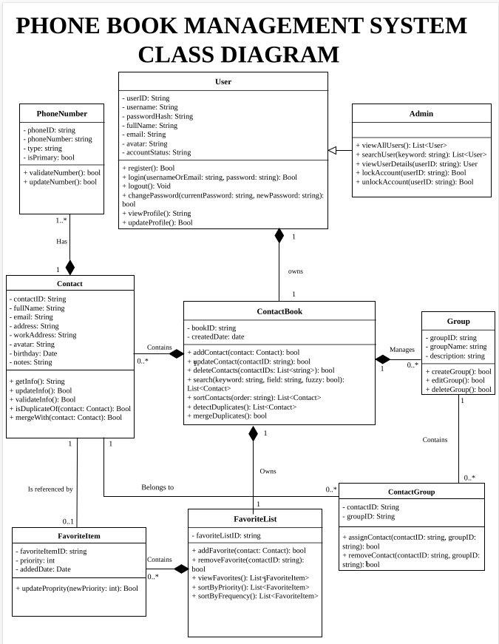
VI. Data Model


